

Name of the event | “Problem Solving Using Quantum Technologies”
Type of Event | Online Workshop
Event Date | 23rd August 2025.
Faculty Coordinators | 1.Dr BHVS Rama Krishnam Raju Convener  2. Dr.K.Venkata Nagendra, Coordinator  3. Dr.L Divya, Co-Coordinator
Faculty Coordinators Mobile Numbers | 6281537006  73824 33662
Student Coordinators | M Pavan P Siva
Student Coordinators Mobile Numbers | 9182382087  93925 14245
Collaboration/Association | Department of Computer Science and Engineering.
Description of the event | This event provides a comprehensive overview of quantum computing principles and their practical applications in addressing complex challenges across various industries. The primary goal is to educate participants on how quantum mechanics can be leveraged to solve problems that are currently intractable for classical computers.
Inauguration Members Attended | 03
Banner | Annexure-1
Inauguration Details | Annexure-2
Event Photos | Annexure-3
Students List | Annexure-4
Sample Certificate | Annexure-5
Students Feedback | Annexure-6

Annexure-1
Banner
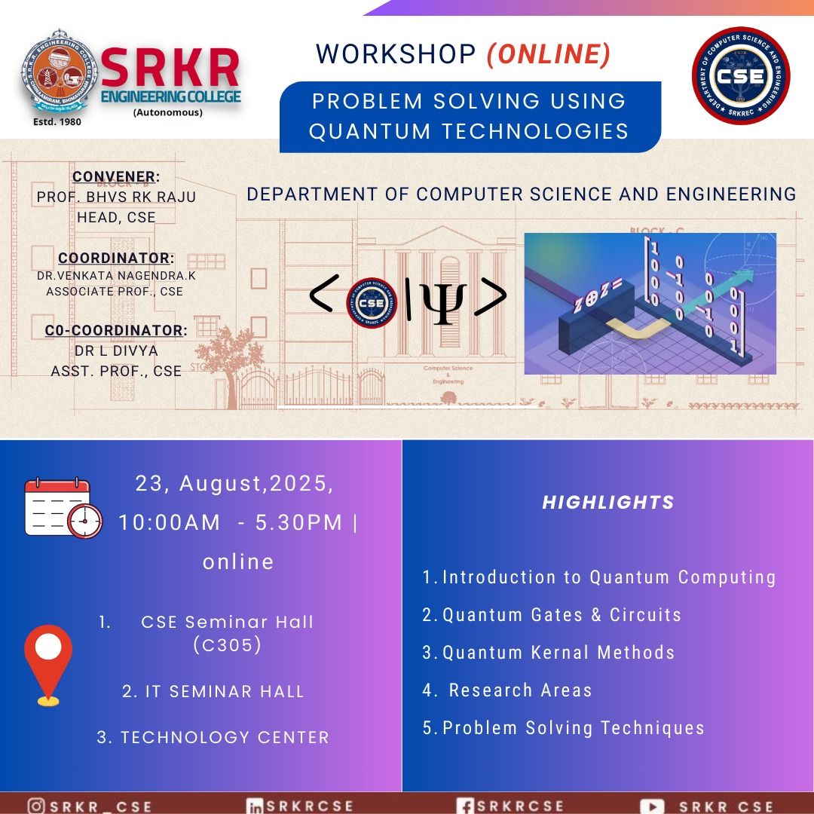
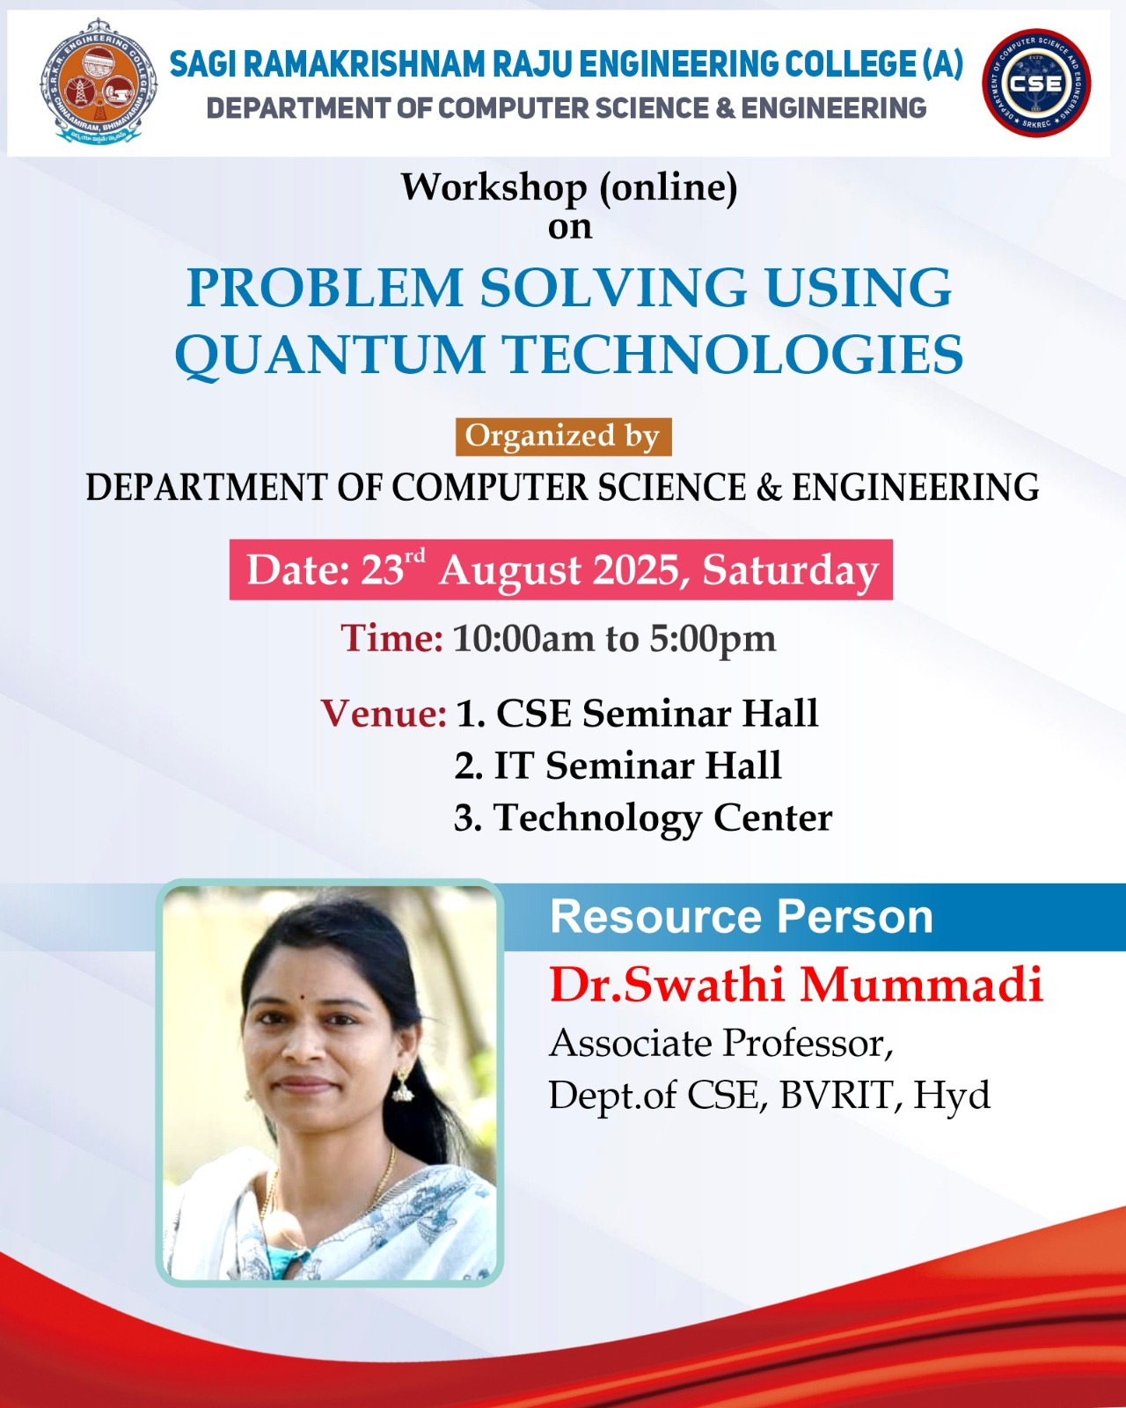

Annexure-2
Inauguration Members Details

NAME | DESIGNATION
1.Dr BHVS Rama Krishnam Raju  Convener | Professor & HOD
2. Dr.K.Venkata Nagendra,  Coordinator | Associate Professor
3. Dr.L Divya  Co-Coordinator | Assistant Professor

Annexure-3

EVENT PHOTOS

MORINING SESSION DATE: 23.08.2025
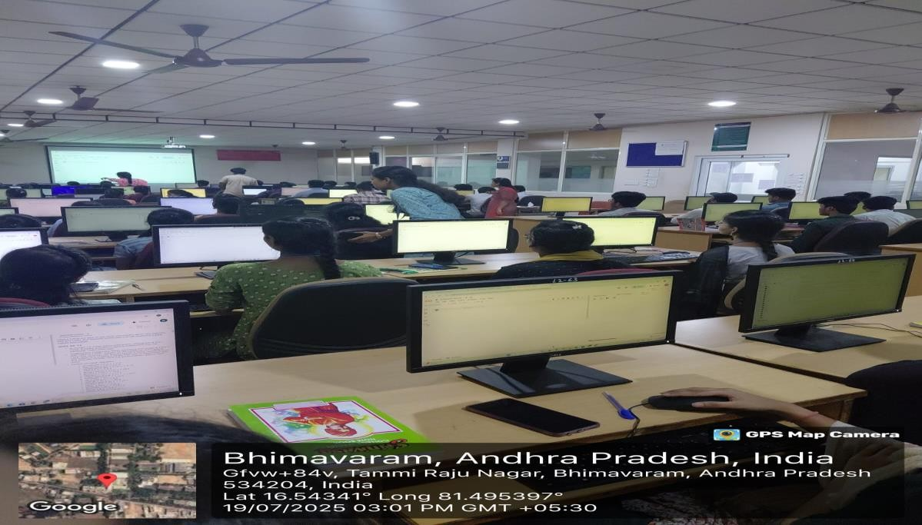

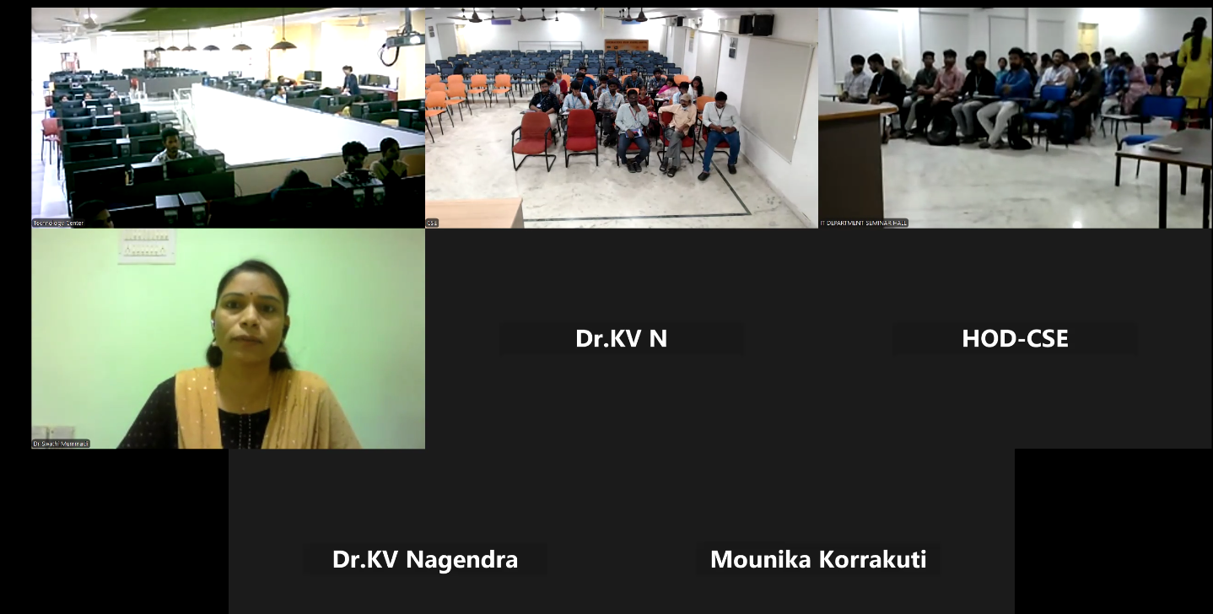

EVENT PHOTOS
AFTERNOON SESSION DATE: 20/07/25
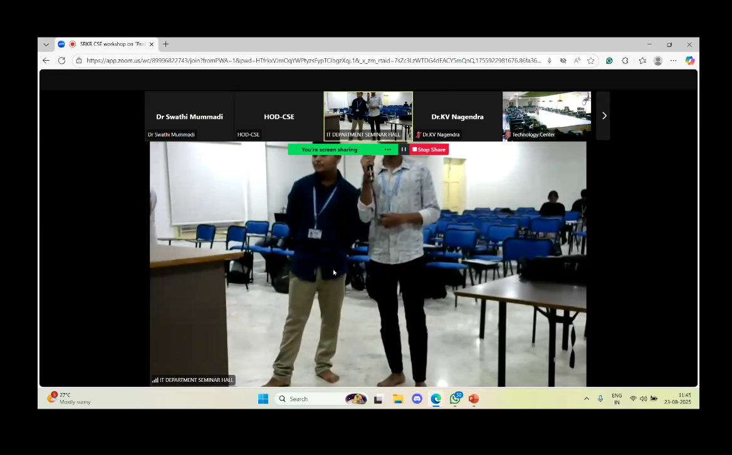

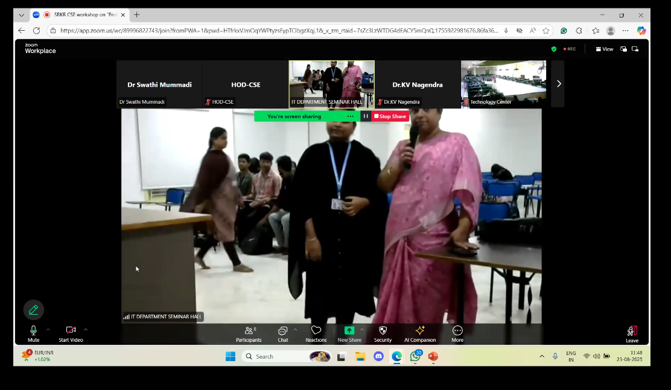

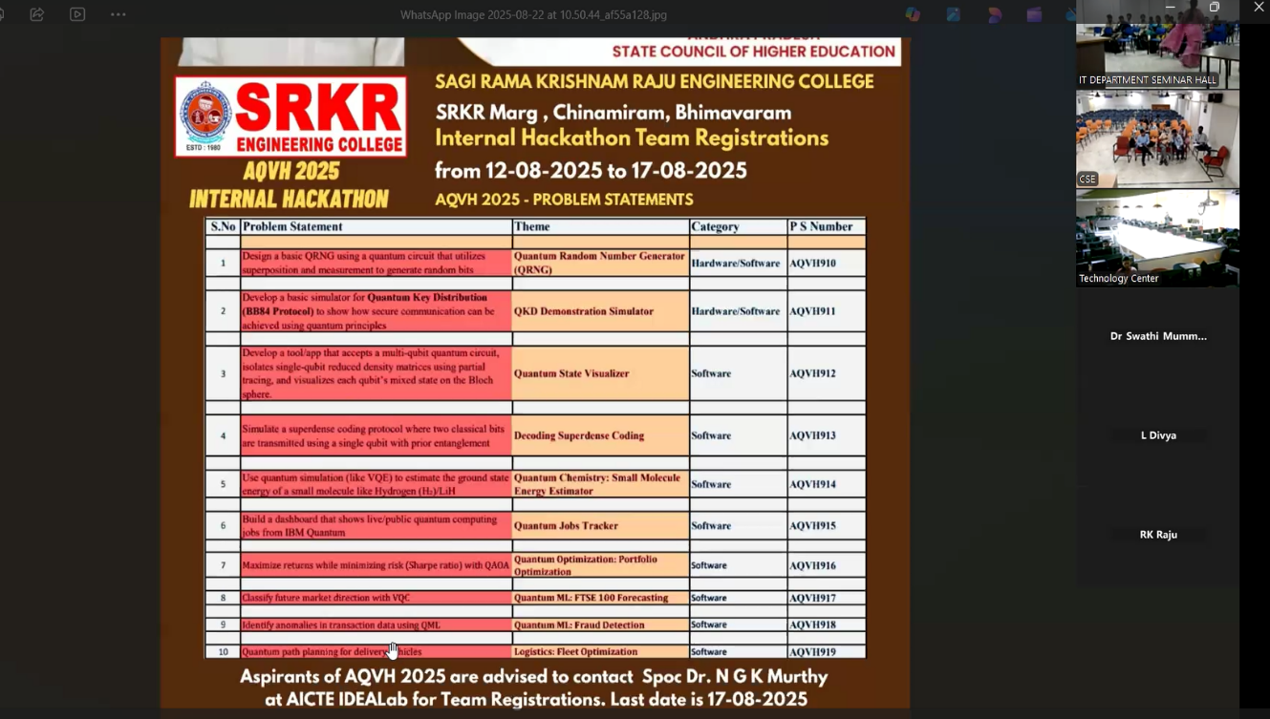
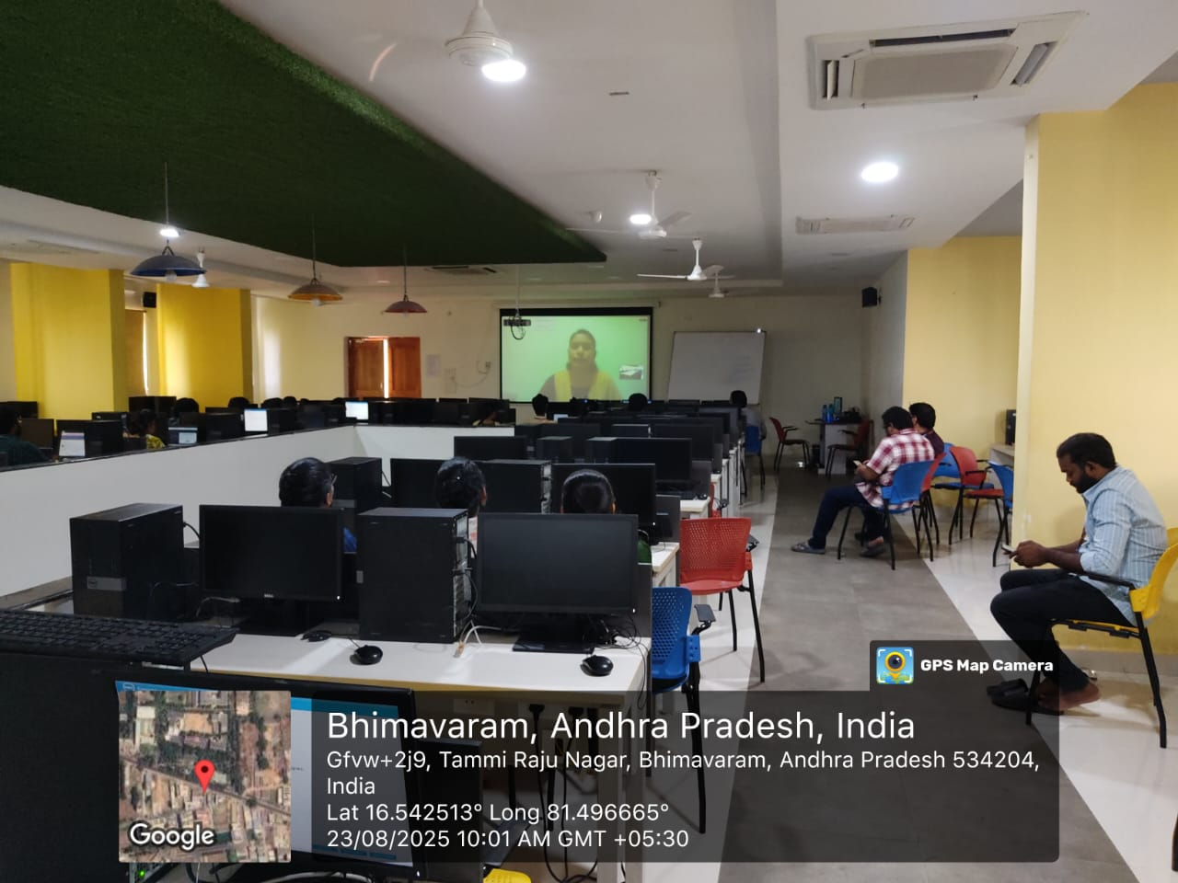

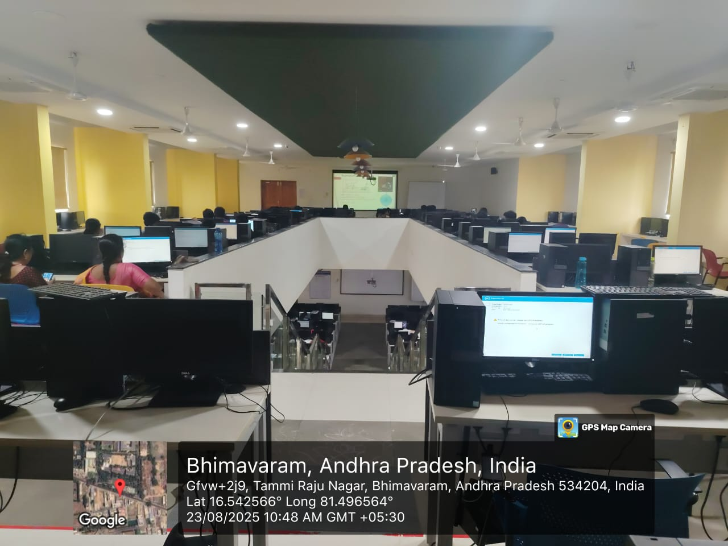
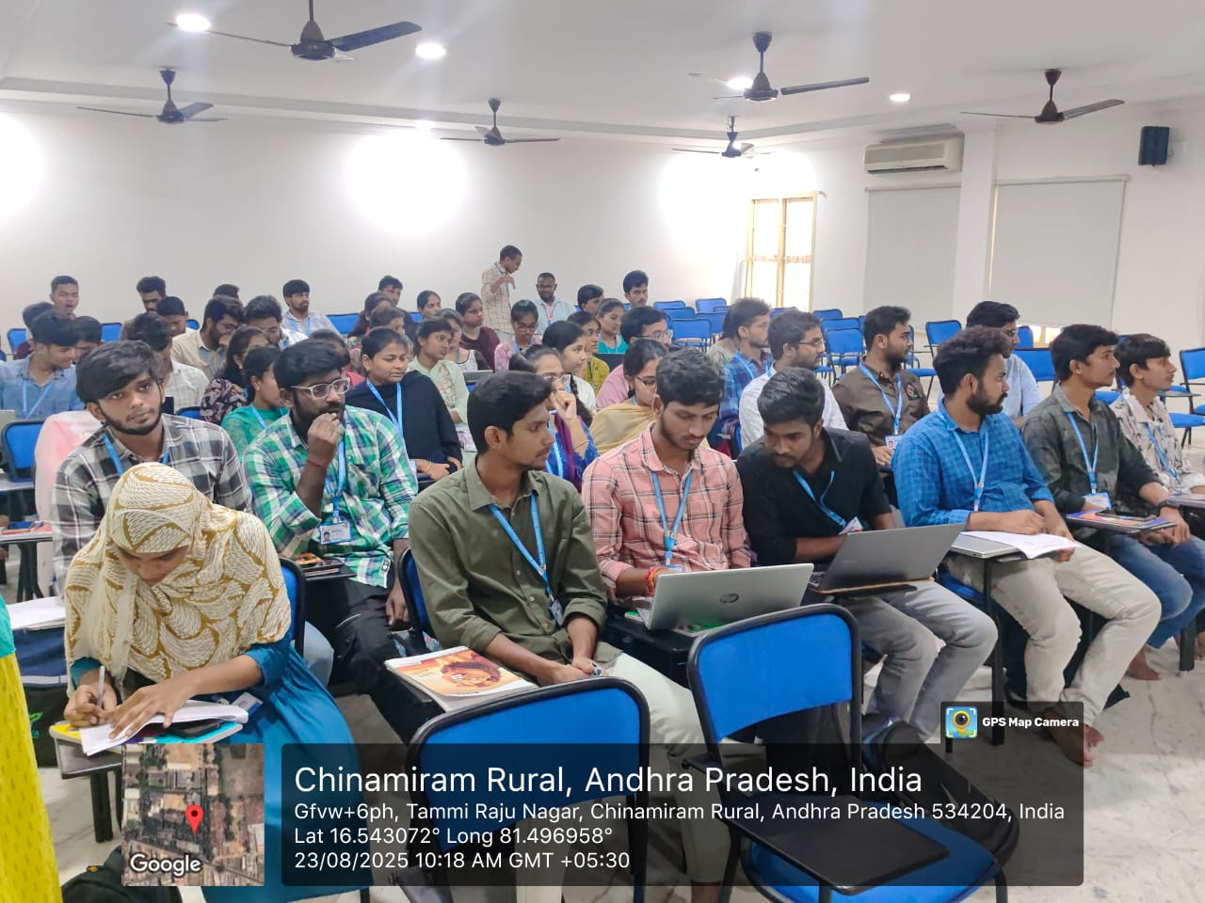

8

ANNEXURE-4
List of Students Registered

S.No | Roll Number | Name | Branch | Year
1 | 24B91A04A9 | L V N S S Shanmukha | ECE | 2nd
2 | 24B91A04A2 | K Madhuri Naga Sri | ECE | 2nd
3 | 24B91A04E2 | P Bhavana | ECE | 2nd
4 | 22B91A0459 | K Deepthi Meghana | ECE | 4th
5 | 24B91A04J2 | V Karthik | ECE | 2nd
6 | 24B91A04E3 | P Sai Rajesh Rohan | ECE | 2nd
7 | 23B91A05T8 | Koushik Thummu | CSE | 3rd
8 | 24B95A6103 | Rajesh Challa | AIML | 3rd
9 | 23B91A6153 | Surya Pravallika Gollakoti | AIML | 3rd
10 | 23B91A6115 | Charan Sai Barnikani | AIML | 3rd
11 | 23B91A61J3 | Lavanya Yandapalli | AIML | 3rd
12 | 23B91A0714 | Nikhila Valli Gottumukkala | CSIT | 3rd
13 | 23B91A54D6 | Pilli Manoj Sai | AIDS | 3rd
14 | 23B91A54D2 | Patapalla Thoran Mani Sangeeth | AIDS | 3rd
15 | 23B91A54D8 | Pothanaboyena Pavan | AIDS | 3rd
16 | 23B91A54D0 | Pasam Venkata Brahmendra | AIDS | 3rd
17 | 23B91A54A9 | Midde Nava Deepika Lakshmi | AIDS | 3rd
18 | 23B91A54C0 | Nagireddy Leela Purna Sai Lakshmi Bhargavi | AIDS | 3rd
19 | 23B91A61G4 | Semalla Vivek | AIML | 3rd
20 | 23B91A54D5 | Perni Balaji | AIDS | 3rd
21 | 23B91A61I7 | Veerla Naga Tirumala Krishna | AIML | 3rd
22 | 23B91A61I5 | V V N S Pavan | AIML | 3rd
23 | 23B91A4729 | Gajja Shanmukha Suraz | CIC | 3rd
24 | 23B91A4754 | Kolli Manasa | CIC | 3rd
25 | 23B91A0410 | A Siddardha Phani Kumar | ECE | 3rd
26 | 23B91A0472 | G Deekshith | ECE | 3rd
27 | 23B91A0411 | A Vamsi | ECE | 3rd
28 | 23B91A0471 | G Keerthi | ECE | 3rd
29 | 23B91A0408 | A Khyatisri | ECE | 3rd
30 | 23B91A0469 | G Bhanu Prakash | ECE | 3rd
31 | 24B91A6136 | Ch Santosh Kumar | AIML | 2nd
32 | 24B91A6127 | C Harsha Vardhan | AIML | 2nd
33 | 24B91A6144 | D Benny Joseph | AIML | 2nd
34 | 24B91A6160 | G Mahitha | AIML | 2nd
35 | 24B91A6117 | B Bhavya Ratna Sri | AIML | 2nd
36 | 24B91A6170 | G Tejaswini | AIML | 2nd
37 | 24B91A6164 | G Rushitha | AIML | 2nd
38 | 24B91A6111 | A Mounika | AIML | 2nd
39 | 24B91A6116 | B Alekhya | AIML | 2nd
40 | 24B91A6121 | B Vijay | AIML | 2nd
41 | 24B91A61D6 | M Manikanta | AIML | 2nd
42 | 24B91A6187 | K Chinna | AIML | 2nd
43 | 23B91A02A2 | Polamuri Chinni Novahu | EEE | 3
44 | 23B91A6108 | Arepalli Asha | AIML | 3
45 | 23B91A6106 | Amrutha Chappa | AIML | 3
46 | 23B91A6138 | Duddupudi J N P Keerthika | AIML | 3
47 | 23B91A61H6 | Tamma Tarun Teja | AIML | 3
48 | 23B91A02B7 | Tadi Mohan Ram Kumar | EEE | 3
49 | 24B91A5453 | Gadepalli Sai Eswar Pranav | AIDS | 2ND
50 | 24B91A05F1 | Vinoliya Kontipudi | CSE | 2ND
51 | 24B91A5452 | Erra Sahithi | AIDS | 2ND
52 | 24B91A0581 | Ishvar Ethakota | CSE | 2ND
53 | 24B91A05U2 | Shaik Gayazuddin | CSE | 2ND
54 | 24B91A0552 | Borusu V R P Trishanth | CSE | 2ND
55 | 23B91A6201 | Addagarla Sri Vidya Sagar | CSD | 3rd
56 | 24B91A5424 | Bodapati Mrudula Kasturi | AIDS | 2nd
57 | 24B91A5415 | Hema Varshini Bhavani Naga Gokul Bandi | AIDS | 2nd
58 | 23B91A0287 | Naralasetti Rama Krishna Sai Charan | EEE | 3rd
59 | 24B91A5455 | Gajula Meena Prasanna | AIDS | 2nd
60 | 24B91A5443 | Balaji Ganesh Devarakonda | AIDS | 2nd
61 | 24B91A0723 | Ch Dileep Ram Kumar | CSIT | 2nd
62 | 24B91A0752 | K Vineel | CSIT | 2nd
63 | 24B91A0766 | M Aswitha | CSIT | 2nd
64 | 24B91A0742 | K Deekshitha | CSIT | 2nd
65 | 24B91A0720 | Ch Vivekannada | CSIT | 2nd
66 | 24B91A0763 | M Kaveri | CSIT | 2nd
67 | 24B91A07B7 | T Johan Benedict | CSIT | 2nd
68 | 24B91A0760 | M Jnanesh | CSIT | 2nd
69 | 24B91A0759 | M Varshini | CSIT | 2nd
70 | 24B91A0739 | J Leela Pavan Krishna | CSIT | 2nd
71 | 24B91A07B2 | S Vivek Sai | CSIT | 2nd
72 | 24B91A0722 | Ch Rachitha | CSIT | 2nd
73 | 23B91A1233 | Ch Vinay Kumar | IT | 3rd
74 | 24B95A1208 | G Mahidar | IT | 3rd
75 | 23B91A1239 | D Syam Sandeep Reddy | IT | 3rd
76 | 23B91A54I5 | V Jyothendra Raju | AIDS | 3rd
77 | 24B95A0428 | K H Surya Teja | ECE | 3rd
78 | 23B91A1247 | G Jyothi Sri | IT | 3rd
79 | 23B91A54G3 | Shaik Inayattulla | AIDS | 3rd
80 | 23B91A54F9 | Settipalli Satyanarayana | AIDS | 3rd
81 | 23B91A54G1 | Shaik Ansari | AIDS | 3rd
82 | 23B91A54G7 | Sunkara Himavanth Sai Manikanta | AIDS | 3rd
83 | 23B91A54H2 | Tamada Harshavardhan | AIDS | 3rd
84 | 23B91A54G2 | Shaik Hafeeza | AIDS | 3rd
85 | 24B95A1206 | Chennuri Lavanya Durga | IT | 3rd
86 | 23B91A12F3 | Savaram Jhansi | IT | 3rd
87 | 24B95A1201 | Bande Shanmukha Priya | IT | 3rd
88 | 23B91A12F7 | Shaik Meera Jasmine | IT | 3rd
89 | 24B95A1217 | Sanam Ramya Sri | IT | 3rd
90 | 24B95A1210 | Marapaka Prasanthi | IT | 3rd
91 | 24B95A1215 | Pindi Dyana Sai Karthik | IT | 3rd
92 | 24B95A1203 | Boyina Prem Sai | IT | 3rd
93 | 24B95A1204 | Buri Gowtham Kumar | IT | 3rd
94 | 24B95A1205 | Chandana Soma Sekhar | IT | 3rd
95 | 24B95A1214 | Pindi Anusha | IT | 3rd
96 | 24B95A1222 | Velugu Anjibabu | IT | 3rd
97 | 23B91A54A0 | M Hanumantha Rao | AIDS | 3rd
98 | 23B91A54B3 | M Sai Nikhil | AIDS | 3rd
99 | 23B91A54A5 | M Harshavardhan | AIDS | 3rd
100 | 23B91A54A4 | M Harish | AIDS | 3rd
101 | 23B91A54B6 | N Mahita | AIDS | 3rd
102 | 23B91A54C5 | P Kumar Sai | AIDS | 3rd
103 | 23B91A54D7 | P Kalyan Kumar | AIDS | 3rd
104 | 23B91A54B0 | M Sai Kumar | AIDS | 3rd
105 | 23B91A54B9 | N Lokesh | AIDS | 3rd
106 | 23B91A54B5 | M Chiranjeevi Raju | AIDS | 3rd
107 | 23B91A5484 | K Kesava Kumar | AIDS | 3rd
108 | 23B91A54B1 | M Habibunnisa | AIDS | 3rd
109 | 24B91A07C7 | D V Nishitha | CSIT | 2nd
110 | 24B91A0773 | M Srinija | CSIT | 2nd
111 | 24B91A0777 | N Thanusha | CSIT | 2nd
112 | 24B91A0786 | P B S Kruthi | CSIT | 2nd
113 | 24B91A6227 | V Lalitha | CSD | 2nd
114 | 24B91A0748 | K Manasa | CSIT | 2nd
115 | 23B91A5452 | G Vijaya Durga | AIDS | 3rd
116 | 23B91A5426 | B Kavya | AIDS | 3rd
117 | 23B91A5409 | A Aditya Satvik | AIDS | 3rd
118 | 23B91A5428 | Ch Saketh | AIDS | 3rd
119 | 23B91A05G2 | M Revanth Srinivas | CSE | 3rd
120 | 23B91A05G1 | M Mohana Venkata Devi Vignesh | CSE | 3rd
121 | 23B91A5435 | Chinthada Murali Naga Raju | AIDS | 3rd
122 | 23B91A5457 | Gotta Kiran Kumar | AIDS | 3rd
123 | 23B91A5456 | Gorremutchu Manu Saviour | AIDS | 3rd
124 | 23B91A5441 | Dangeti Satya Sai Charitha | AIDS | 3rd
125 | 23B91A5446 | Doddipatla Sharmila | AIDS | 3rd
126 | 23B91A5420 | Bodda Nikitha | AIDS | 3rd
127 | 23B91A5424 | Bolla Siva Naga Babu | AIDS | 3rd
128 | 23B91A5462 | Gurram Chandra Kiran | AIDS | 3rd
129 | 23B91A5463 | Pillada Hari Purna | AIDS | 3rd
130 | 23B91A5433 | Chilukuri Jaya Prakash | AIDS | 3rd
131 | 23B91A5461 | Gunipalli Lakshmi Durga | AIDS | 3rd
132 | 23B91A5413 | Bokka Naga Venkata Lakshmi Goud | AIDS | 3rd
133 | 23B91A5472 | Javvadi Devi Naga Deepika | AIDS | 3rd
134 | 23B91A5405 | Alluri Ramya | AIDS | 3rd
135 | 23B91A5469 | Jalla Valli Bhargavi | AIDS | 3rd
136 | 23B91A5412 | Athota Nikitha | AIDS | 3rd
137 | 23B91A5471 | Jampana Sai Pavan Kumar Varma | AIDS | 3rd
138 | 23B91A5434 | Chinnam Bhagya Teja | AIDS | 3rd
139 | 23B91A5459 | G Kiran Babu | AIDS | 3rd
140 | 23B91A5470 | J Purna Surya Chandra Raju | AIDS | 3th
141 | 23B91A4719 | B Leela Likitha | CIC | 3rd
142 | 23B91A5407 | A Guna Sekhar | AIDS | 3rd
143 | 23B91A5473 | J Satya Siva Durga Pavan | AIDS | 3rd
144 | 23B91A4726 | D Dreamy Havilah | CIC | 3rd
145 | 23B91A5408 | Alalith Vignesh | AIDS | 3rd
146 | 23B91A5404 | Ayugandhar | AIDS | 3rd
147 | 23B91A5425 | Bsudhakar | AIDS | 3rd
148 | 23B91A5466 | Isneha | AIDS | 3rd
149 | 23B91A5451 | Grekha Sri | AIDS | 3rd
150 | 23B91A5406 | Ajayanth Kumar | AIDS | 3rd
151 | 22B91A0501 | Thota Sujay Babu | CSD | 4
152 | 23B91A0520 | Thota Mohan Siva | CSD | 3
153 | 24B91A0584 | Naga Satya Sai Vamsi Kiran Ande | CSD | 4
154 | 23B91A0590 | Tanukula Uma Sai Pavan | CSD | 3
155 | 23B91A0518 | Gummalla Naga Gayathri | CSD | 3
156 | 23B91A0517 | Durga Bhavani Kopparthi | CSD | 3
157 | 24B95A5402 | Beduthuri Tejeswar Reddy | AI&DS | 3rd
158 | 24B95A5408 | Mandapati Satya Nivas | AIDS | 3rd
159 | 24B95A5404 | Dosa Dheeraj Sri Sai | AIDS | 3rd
160 | 23B91A54F5 | SANAPALA CHANDU | AIDS | 3rd
161 | 24B95A5409 | MEDA ASWITHA PRIYA | AIDS | 3rd
162 | 24B95A0501 | BANAVATHU LAKAHMAN | cse | 3 rd
163 | 24B95A5411 | Nalluri Wesly | AIDS | 3rd
164 | 23B91A54J2 | Yalla Jaswanth | AIDS | 3rd
165 | 24B95A5412 | PITCHUKA NAGA SYAMALA KARTHIK | AIDS | 3rd
166 | 23B91A54I4 | VASAMSETTI SIVA RAM | AIDS | 3rd
167 | 23B91A54G0 | SETTYPALLY RAJA SWETHA | AIDS | 3rd
168 | 23B91A5496 | GIRISHA PRATHIMA KUNUKU | AIDS | 3rd
169 | 24B95A5413 | Shaik Khajavali | AIDS | 3rd
170 | 24B95A5414 | SHAIK LIYAKHAT YUSUF RAZA | AIDS | 3rd
171 | 24B95A5416 | TALLA SUBHASH | AIDS | 3rd
172 | 23B91A54G6 | Somepalli Siva Naga Lakshmi | AIDS | 3rd
173 | 23B91A5482 | Kanamarlapudi V Siva Naga Sai Anjani Kumar | AIDS | 3rd

ANNEXURE-5
Sample Student Certificates

ANNEXURE-6

Students Feedback

Total Students Registered | 173
Total Responses | 158

